English Worksheet
Reading Comprehension Activity

Name: Date:

PRE-READING:
ANSWER THE NEXT QUESTIONS:
1.- Do you have grandparents? How old are they?
2.- Have you ever visited a nursing home?
3.- Is there any nursing home in your city?
READING:

The Mole Agent' infiltrates a nursing home, and Hollywood
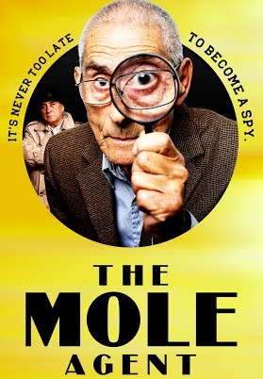
“The Mole Agent” infiltrated a nursing home in Chile, and countless of hearts around the world including inside the film academy.
The moving documentary about an octogenarian hired as a rookie spy to investigate whether a client’s mother is suffering abuse in the facility is competing for an Oscar this Sunday, but director Maite Alberdi constantly doubted whether she would have enough for a movie.
“I think the main challenge was that we were walking on eggshells,” said Alberdi, who on one hand feared that her protagonist Sergio Chamy would get tired and resign, or that the home's officials would discover that he was not just another tenant or that she was not actually filming a documentary about the life of the elderly, as she had told them. The director came in a few days before Chamy, and they both pretended the whole time that they didn’t know each other.
Alberdi, 38, spoke recently with The Associated Press about the risks and challenges of the the three-and-a-half month shoot, the use of humor to address issues as sensitive as loneliness and abandonment at the dusk of life, and how the experience affected her.

READ THE TEXT ABOVE AND CHOOSE THE RIGHT ALTERNATIVE:
1.- What is “The Mole Agent”?
a) A song b) A Cartoon c) A documentary movie
2.- Where was it made?
a) In a hospital b) In a nursing home c) In a school.
3.- Who is the main character?
a) A young man b) A boy c) An old man.
4.- Who is the director?
a) Sergio Chamy b) Maite Alberdi c) Oscar.
READ AGAIN AND ANSWER THE NEXT QUESTIONS:
1.- What is “The Mole Agent about?
…………………………………………………………………………………………………………………………………
……………………………………………………………………………………………………………………….………..
2.- What do you think is the meaning of “walking on eggshells”?
…………………………………………………………………………………………………………………………………
…………………………………………………………………………………………………………………………………
3.- Which were the main challenges that the director had to face while they were filming the documentary?
…………………………………………………………………………………………………………………………………
…………………………………………………………………………………………………………………………………
…………………………………………………………………………………………………………………………………

POST READING:
Answer:
Have you watched this movie?
………………………………………………………………………………………………………..…..
What is your opinion about the movie?
………………………………………………………………………………………………………………
………………………………………………………………………………………………………………
Are the elderly well treated in your community?
………………………………………………………………………………………………………………
INTERVIEW AND OLD PEOPLE, TAKE SOME NOTES AND THEN WRITE A SMALL ESSAY ABOUT IT.
Name, age, nationality, likes, dislikes
How does he/she feel being an elderly?
Do you think that your country is worried about the elderly?
Do you feel respected and happy?
What is the worst part of being an elderly?

