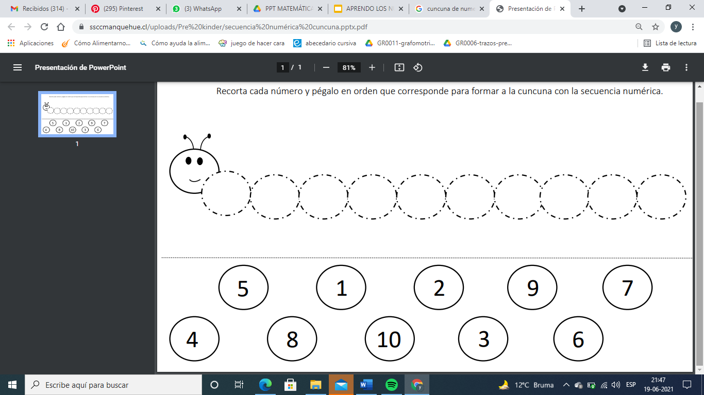Nombre: __________________________________________________________________________

